# Worksheet 3a Functions Answers

1. **Create a series of functions for a robot to do your household chores**

e.g. Washing up, vacuuming, making the bed

Add some function calls at the end of the program so that the robot will do them

Your answer should look something like this:

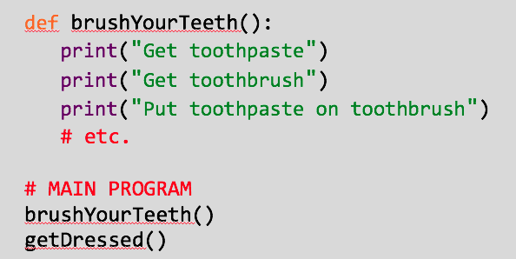

Example:

def washUp():  
 print(“Fill bowl with hot, soapy water”)  
 print(“Clean glasses and cups”)  
 print(“Clean knives and forks”)  
 print(“Clean plates and bowls”)  
 print(“Clean saucepans”)  
  
def makeBed():  
 print(“Take clothes / electronics / rubbish off bed”)  
 print(“Put pillows back”)  
 print(“Spread quilt over bed”)  
  
# MAIN PROGRAM

makeBed()  
washUp()

1. **Tic - Tac - Toe**

Use the following function calls to put together a complete game of Tic Tac Toe.

Rewrite them and repeat them (on paper) in an order that would allow you to play the game. You can do this as a flowchart instead if you prefer.

Test the game by playing against someone else (you play as the player, they play as the computer). Neither one is allowed to do anything that isn’t in the program you’ve designed.

drawGrid()  
playerChooses()  
checkIfSomeoneWon()  
computerChooses()  
checkIfSomeoneWon()

***See program L3 WS3a Ex 2 tic_tac_toe.py for a sample outline solution for students to complete.***

Any sensible solution – key thing is to test this thoroughly.

Read ahead and see answer to Task 3 for an example.

1. **Tic - Tac - Toe**

Download the Tic Tac Toe program (L3 WS3a Ex2 tic_tac_toe.py).

The subroutines are already completed for you, all you need to do is uncomment the calls at the bottom of the program. You can copy each one as many times as you need to.

Test the program thoroughly – make sure it works if you win, lose or draw (it might take a few goes to lose successfully!)­.

***See program L3 WS3a Ex 3 tic_tac_toe complete.py for a sample solution.***

***Program L3 WS3a Ex 3 tic_tac_toe with loop.py is an alternative solution using a loop.***

Other solutions may be valid and may well be more efficient.

Key is to use only the code that is provided. No new code (other than loops, potentially) should be used. Checking of who won and ending the program are already completed.

It is not expected that the students will explore the content of the subroutines in any great depth, though enthusiastic students may find it useful.